VVTG 2024 –Notes Page and Variety Links

This document is optional to use. Its purpose is to provide a space for your notes and to include direct links to each trial variety on the VVfG website for beds 1-9. You do not need to add images on the ratings website.
Images should be uploaded to Cornell Box: (beds mid-season, the beds with mature plants before harvest, and images of your top 3 or 4 vegetable variety picks (Mature plant with vegetable). If possible, please label images before uploading them to the Cornell Box folder. Example: Heat and Sweet Peppers Bed – mid-season

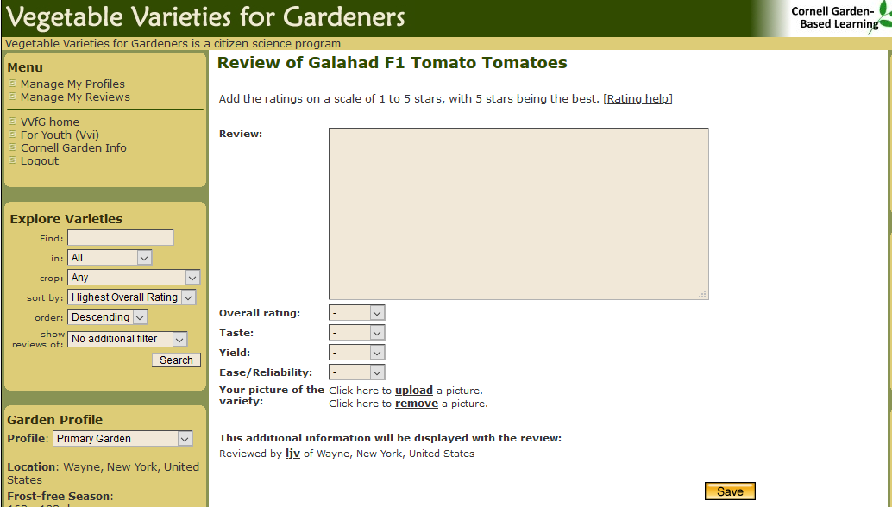
Ratings for the VVfG Website:

I you choose to use this form, you will still need to enter your ratings and any comments on the variety into the VVfG website for each variety that you grow.

To enter your notes, first click on “fill and sign”.

If you have any questions about reporting please contact Laurie at ljv8@cornell.edu

Thank you!

Vegetable  Variety | Image: Mid-Seasongrowth | Image: Mature Plants before harvest | Image: Harvested Vegetables | Ratings for the VVfG website.  Score 1 - 5 | Vegetable Varieties for Gardeners link  and  Variety notes to add to the VVfG website.
Tomato  ‘Cosmonaut Volkov’ |  |  |  | Overall:  Taste:  Yield:  Reliability: | Link to VVfG Site: https://vegvariety.cce.cornell.edu/main/detail.php?variety_id=1545&filterBy=  Notes:
Cucumber  ‘Ukrainian Slicing’ |  |  |  | Overall:  Taste:  Yield:  Reliability: | Link to VVfG Site: https://vegvariety.cce.cornell.edu/main/detail.php?variety_id=7721&filterBy=  Notes:
Parsley  ‘Gigante d’Italia’ |  |  |  | Overall:  Taste:  Yield:  Reliability: | Link to VVfG: https://vegvariety.cce.cornell.edu/main/detail.php?variety_id=1138&filterBy=  Notes:
Vegetable  Variety | Image: Mid-Seasongrowth | Image: Mature Plants before harvest | Image: Harvested Vegetables | Ratings for the VVfG website.  Score 1 - 5 | Vegetable Varieties for Gardeners link  and  Variety notes to add to the VVfG website.
Dill  ‘Bouquet’ |  |  |  | Overall:  Taste:  Yield:  Reliability: | VVfG Site: https://vegvariety.cce.cornell.edu/main/detail.php?variety_id=7083&filterBy=  Notes:
Basil  ‘Genovese’ |  |  |  | Overall:  Taste:  Yield:  Reliability: | VVfG Site: https://vegvariety.cce.cornell.edu/main/detail.php?variety_id=2566&filterBy=  Notes:
Vegetable  Variety | Image: Mid-Seasongrowth | Image: Mature Plants before harvest | Image: Harvested Vegetables | Ratings for the VVfG website.  Score 1 - 5 | Vegetable Varieties for Gardeners link  and  Variety notes to add to the VVfG website.
Mint – No Rating |  |  |  | Overall:  Taste:  Yield:  Reliability: | VVfG Site: No Rating for this plant. Optional to grow – pollinators will appreciate it if you do!  Notes:
Chili Pepper  ‘Bulgarian Carrot’ |  |  |  | Overall:  Taste:  Yield:  Reliability: | VVfG Site: https://vegvariety.cce.cornell.edu/main/detail.php?variety_id=2230&filterBy=  Notes:
The varieties below are for the 5 bed planting design and are also included in the 9 bed planting design.
Dry Bean  ‘Robert Hazelwood’ |  |  |  | Overall:  Taste:  Yield:  Reliability: | VVfG Site:  Notes:
Vegetable  Variety | Image: Mid-Seasongrowth | Image: Mature Plants before harvest | Image: Harvested Vegetables | Ratings for the VVfG website.  Score 1 - 5 | Vegetable Varieties for Gardeners link  and  Variety notes to add to the VVfG website.
Carrot  ‘Danvers’ |  |  |  | Overall:  Taste:  Yield:  Reliability: | VVfG Site: https://vegvariety.cce.cornell.edu/main/detail.php?variety_id=4355&filterBy=  Notes:
Radish  ‘Cherry Bell’ |  |  |  | Overall:  Taste:  Yield:  Reliability: | VVfG Site: https://vegvariety.cce.cornell.edu/main/detail.php?variety_id=1355&filterBy=  Notes:
Vegetable  Variety | Image: Mid-Seasongrowth | Image: Mature Plants before harvest | Image: Harvested Vegetables | Ratings for the VVfG website.  Score 1 - 5 | Vegetable Varieties for Gardeners link  and  Variety notes to add to the VVfG website.
Beet  ‘Detroit Dark Red’ |  |  |  | Overall:  Taste:  Yield:  Reliability: | VVfG Site: https://vegvariety.cce.cornell.edu/main/detail.php?variety_id=165&filterBy=  Notes:
Cabbage  ‘Early Jersey Wakefield’ |  |  |  | Overall:  Taste:  Yield:  Reliability: | VVfG Site: https://vegvariety.cce.cornell.edu/main/detail.php?variety_id=273&filterBy=  Notes:
Vegetable  Variety | Image: Mid-Seasongrowth | Image: Mature Plants before harvest | Image: Harvested Vegetables | Ratings for the VVfG website.  Score 1 - 5 | Vegetable Varieties for Gardeners link  and  Variety notes to add to the VVfG website.
Potato  ‘Elba’ |  |  |  | Overall:  Taste:  Yield:  Reliability: | VVfG Site: https://vegvariety.cce.cornell.edu/main/detail.php?variety_id=1440&filterBy=  Notes:
Onion  ‘Clear Dawn’ |  |  |  | Overall:  Taste:  Yield:  Reliability: | VVfG Site: https://vegvariety.cce.cornell.edu/main/detail.php?variety_id=505&filterBy=  Notes:

